BACKWARD CHAINING

AIM: To implement a prolog program for Backward Chaining.

OBJECTIVES:
- To implement backward chaining in Prolog, where the system starts with a goal and works backward to determine whether the required facts can satisfy the goal.
ALGORITHM:
- Start with a goal.
- Check whether the goal is already a known fact.
- If not, find a rule whose conclusion matches the goal.
- Treat the rule's conditions as sub-goals.
- Recursively prove each sub-goal.
- If all sub-goals are satisfied, the original goal is true.

SYSTEM-ARCHITECTURE:
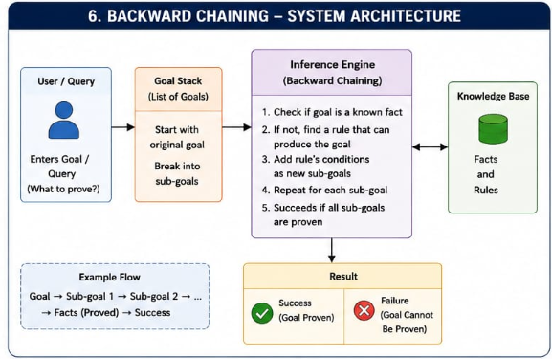

PROGRAM:
% Backward Chaining

fact(sunny).
fact(warm).

rule(happy) :-
fact(sunny),
fact(warm).

rule(go_outside) :-
fact(sunny).

% Backward chaining
prove(Goal) :-
fact(Goal).

prove(Goal) :-
rule(Goal).

OUTPUT:
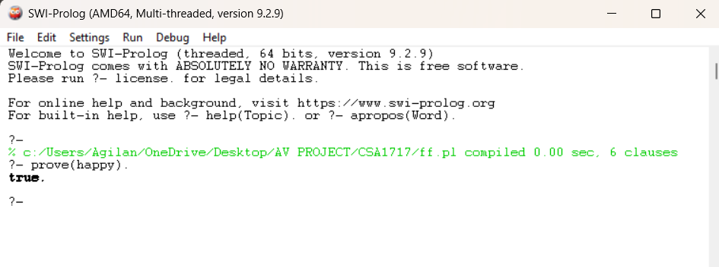

RESULT: Thus the backward Chaining is implemented successfully using Prolog program.

